1. User Stories.

|  |  |
| --- | --- |
| As a Costumer: | 6 |
| I want: | See the menu card. |
| So that: | So I can order a pizza. |

|  |  |
| --- | --- |
| As a Costumer: | 1 |
| I want: | To Order a pizza. |
| So that: | I can eat it. |

|  |  |
| --- | --- |
| As a Costumer: | 7 |
| I want: | Get my pizza delivered |
| So that: | So I can stay home and eat pizza |

|  |  |
| --- | --- |
| As a Costumer | 2 |
| I want: | See the price |
| So that: | I order pizza |

|  |  |
| --- | --- |
| As a Costumer: | 8 |
| I want: | Change pizzas topping |
| So that: | I can get extra topping. |

|  |  |
| --- | --- |
| As a Costumer: | 3 |
| I want: | Pick up my pizza myself |
| So that: | I can take it home. |

|  |  |
| --- | --- |
| As a Employee: | 9 |
| I want: | See the Orders with timestamps. |
| So that: | Make pizza for my costumers |

|  |  |
| --- | --- |
| As a Costumer: | 4 |
| I want: | To pay with Credit card |
| So that: | I can order my pizza. |

|  |  |
| --- | --- |
| As a Employee: | 10 |
| I want: | I want to see costumer information. |
| So that: | I can deliver it to the right address. |

|  |  |
| --- | --- |
| As a Owner: | 5 |
| I want: | See todays earnings. |
| So that: | I manage business |

1. Domain Diagram

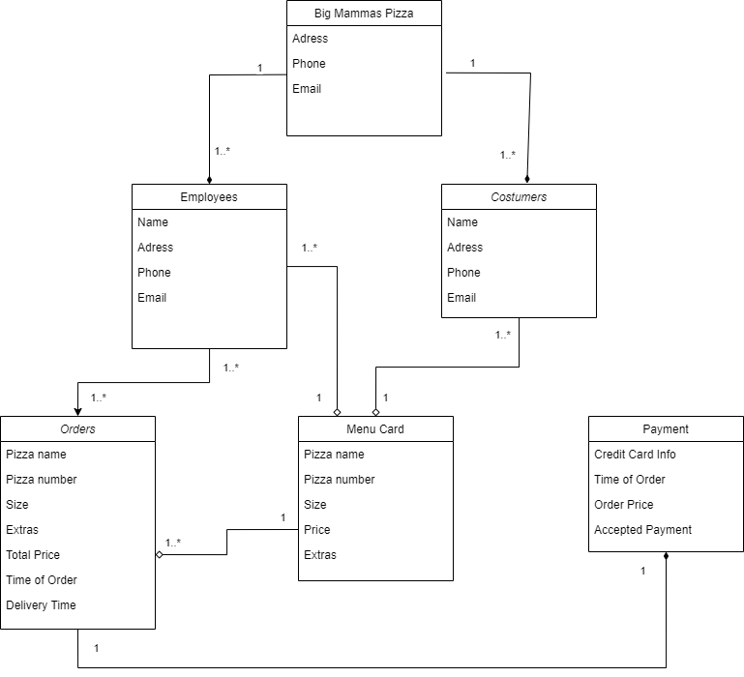

1. Case Diagram

